**A success story of Mr. Fidelis Pendeza Mlowe, a model farmer in Mwakaganga village.**

Mr Fidelis Pendeza Mlowe is a small-scale farmer at Mwakaganga village in Mbarali District about 130 kilometers from Mbeya town. He is one of beneficiaries of Africa RISING-NAFAKA project. I heard about the new project from NAFAKA staff Mr. Datius and extension officer of Mwendamtitu irrigation scheme said “Mr Mlowe’’. Before the project introduced to our community I used to grow local varieties Indiarangi and Fayadume without applying good agricultural practices. The harvest yield I got was very low between 18 to 20 bags with 60 kilograms of seeds per acre. I could not attend any training on rice production. The main challenges he mentioned was weather variability and diseases in the field. I couldn’t able to tell what happening to my plants is either disease; drought or nutrient deficiency explains Mr Mlowe.

“The first time I heard about TXD306 popular known as SARO 5 I was anxious and believed it will be difficult to put on the market. I feared the customers will go for local variety because of aroma. After attending training on good agricultural practices on rice production trained by TARI Dakawa researchers in collaboration with NAFAKA, my yield has been increasing”, Mr Mlowe noted.

Further He said, “In 2017 season I started growing TXD 306 (SARO5) using appropriate fertilizer rates which triggered yield increase from 18-20 bags with local varieties, to 30 bags per acre with 10 kilograms of seeds per acre. In 2018 and 2019 seasons I managed to harvest 38 and 47 bags per acre, respectively with 10 kilograms of seeds”. Mr Mlowe is now producing quality declared seed (QDS) and enjoys a good price of seed as compared to normal grain. For each kilogram I sell for tshs 1,500/=”

“With growing SARO5 I can feed my family, and the income generated enabled me to cover health costs, pay loan for power tiller, improve my house, and pay school fees for my children,” explains Mr Mlowe a rice producer in Mbarali district. The main challenges facing Mr Mlowe and his neighbor rice producers in Mbarali is poor irrigation infrastructure facilities which sometimes caused huge losses in their farm produces. In 2020 year, Mr Mlowe plans to construct a modern house and expanding his farm. He now owns six acres as compared to two acres before started growing SARO5.

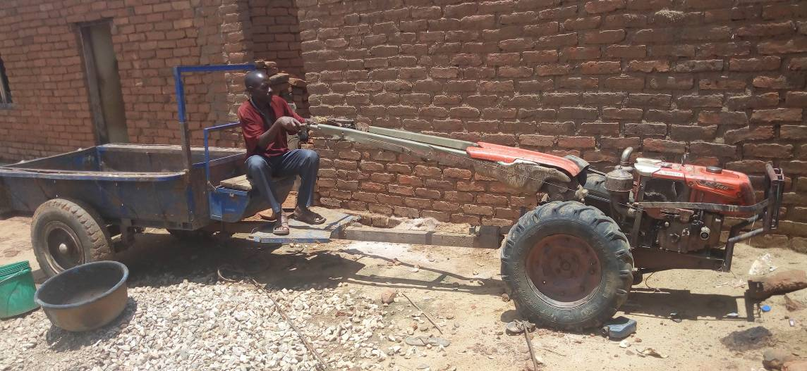

Figure : Mr Mlowe sitting in his power tiller at his house in Mwakaganga village. Photo Credit: Didas Kimaro

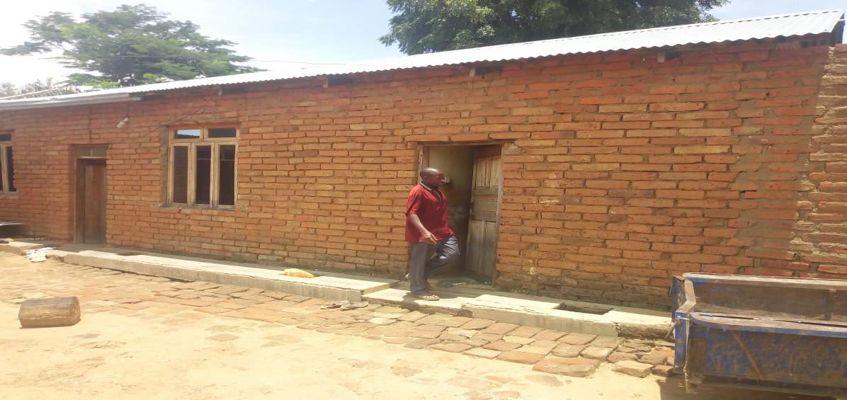

Figure : Mr Mlowe posses in a photo at his house after renovating. Photo Credit: Dr Didas Kimaro

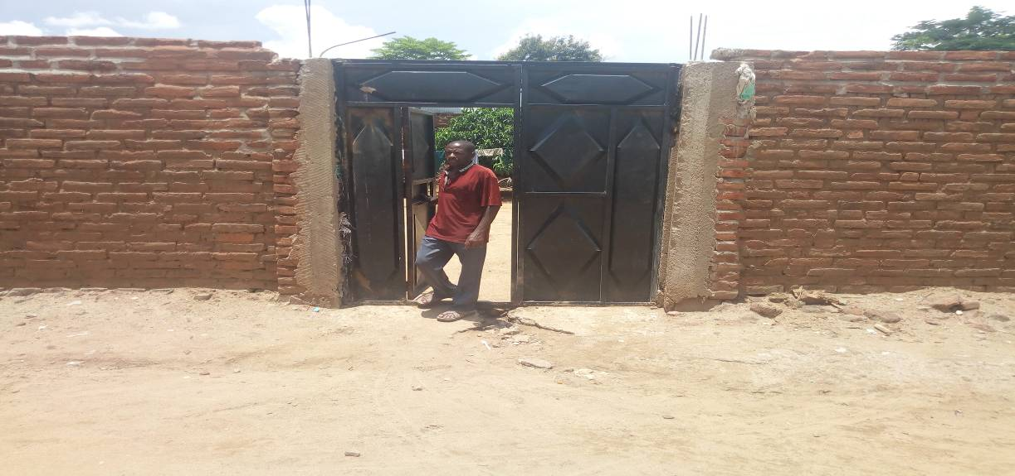

Figure : Mr Mlowe standing in his gate as he has completed build the wall. Photo Credit: Didas Kimaro