TANZANIA AGRICULTURAL RESEARCH INSTITUTE

Quarterly Report on Research, Management and Coordination Progress

For the period of 1st October to 31th December 2022

Prepared by:
Fred Tairo (Ph.D)

Coordinator for Research and Innovation
TARI Mikocheni

31th December 2022

Abbreviations and Acronyms
AVRDC African vegetable research and development centre
BMGF Bill & Melinda Gates Foundation
BBSRC Biotechnology and biological sciences research council
CIMMTY International Maize and Wheat Improvement Centre
COSTECH Commission for science and technology
EAT East African Tall
EAV-IPMIL East African vegetable integrated pest management initiative laboratory
FAO Food Agriculture organization
NAB National Australia Bank
ICIPE International centre for insect physiology and ecology
IPM Integrated pest management
NaCRRI National crop research resources Institute
NCDP National coconut development program
NRI Natural Resource Institute
NCSU North Carolina state University
SPLCV Sweet Potato Leaf Curly Virus
TARI-MKN Tanzania agricultural Research Institute Mikocheni
TOSCI Tanzania official seed certification agency
USAID United State of Agency for International Development

1. Introduction
Tanzania Agricultural Research Institute-Mikocheni (TARI-MKN) is one of the 17 research centres under TARI. It was established in March 1996 as a measure to sustain and institutionalize coconut research and development activities conducted by the then National Coconut Development Programme (NCDP). The NCDP was established by the Government of the United Republic of Tanzania in the fiscal year 1979/80 with the aim to promote coconut production and utilization in the country. The program covered the whole coastal belt of Tanzania and the Island of Zanzibar.
TARI-Mikocheni mandate is in two-folds, namely conduct and promote research for the development of the coconut sub-sector and promote research and utilization of agricultural biotechnology for socio-economic development in the country.
The centre’s head office is in Dar es, salaam at Mikocheni B, Plot 22 along the Coca cola Road. It has two sub-stations, namely Chambezi and Mkuranga, where most of the research activities are conducted. The former is located about 55 km north of Dar es salaam near Bagamoyo town at latitude S6.52⁰ and longitude E 38.91⁰, while Mkuranga sub-station is located at S 7.12⁰ and longitude E 39.20⁰, about 50 km south of Dar es salaam.
There are two departments: 1) Research and Innovation and, 2) Technology Transfer and Partnership. Under these departments there are six subprograms: crop research, natural resources, post-harvest management, socioeconomics and marketing, technology dissemination, commercialization and partnership, and knowledge management and communication programs. The institute is within the eastern zone together with TARI Kibaha and TARI Mlingano.
The Mikocheni centre basically has two research programs, which are its mandates: coconut and biotechnology. The coconut program is the main with 4 research units which include: agronomy, disease control, pest control, social economy, post-harvest and technology transfer, the biotechnology program accommodate 3 units: tissue culture, molecular diagnostics and genetic engineering laboratories. All the research activities in each unit in the coconut program are designed to address all agricultural challenges facing the coconut agro-ecological systems. whereas in biotechnology as a tool cuts across all crops and supports other research mandates.
Research at TARI-Mikocheni has mainly depended on government competitive grants through Commission for science and technology (Costech) and external support from different international funding organisations mainly the “Bill & Melinda Gates Foundation” (BMGF), Bio innovate Africa II, Biotechnology and Biological sciences research council (BBSRC), Food and Agriculture Organization (FAO), World Vegetable Centre and International Centre for Insect Physiology and Entomology (Icipe). In this quarter four (4) starting from 1st October to 31stDecember 2022, the institute operated four (3) research projects with financial support of Tshs. 33, 303,106 (69.46%) is from the International donor support while (30.54%) is from Tanzania government as operational costs.
Thus, using the available support, the institute recorded significant achievements in research activities by: conducting harvesting of cassava field trials for African cassava whitefly research, planting of pineapple on farm results demonstration fields in Njombe and Morogoro, and upscaling of new improved varieties of amaranths and African eggplants through farmers groups demonstration plots into four districts in coast and dares salaam regions and continue with rehabilitation of its coconut file trials in Chambezi and Mkuranga sub stations.
In line with research activities, the institute also continued with the production of quality hybrid sisal seedlings, banana and pineapple MD-2 varieties as well as selling of East African Tall coconut seedlings to various farmers from Kagera, Morogoro and coast regions.

2.0 Research Programs/Activities conducted in this quarter

2.1 Coconut research program
The centre continued to maintain its coconut germplasm, seed nursery and weeding in coconut and mango orchards. Currently, the coconut nursery has sold over 3,563 seedlings as part of 10,000 seedlings raised last year.

The planned activities in this reporting period were:
- Maintenance of coconut nursery and selling of seedlings
- Clearing of bushes and weeding in coconut trials
- Sowing of new coconut seedlings for next season
Achievement
- A total of 3,563 seedlings were established in the seedling nursey for raising seedlings
- A total of 900 coconuts were used for extraction of virgin coconut oil
- Completion of coconut proposal and submission to the Ministry of Finance (Treasurer) for submission to the European Union for funding.
- At Mkuranga, 21 acres for breeder’s test materials (BTMs II &III) for evaluation of hybrids was weeded
Table 1: Quantity of Seed/seedling and coconut by product sold as of 31st December 2022
Product | Categories | Quantity sold | Price per unit | Total amount realised (TZS)
Coconut | Cooking | 0 | 0 | 0
Coconut | Seedlings | 3,563 | 2,500.00 | 8,908,410.00
Dead coconut | Logs | 0 | 0 | 0
Oil palm | Bunches | 0 | 0 | 0
Grand total |  | 3,563 |  | 8,908,410 00

- The proposal was completed and submitted to the treasure, who submitted to the European Union. The proposal was acknowledged and they will get back to us soon. The same proposal was submitted to TARI Hq. for endorsement and will also be submitted by the permanent secretary for Agriculture. However, the final submission to EU has stalled because we are yet to receive endorsement from the Permanent Secretary of Ministry of Agriculture.

Disease control unit
    - Pest control unit
In this reporting period the unit planned to achieve the following activity:
- to continue with project proposal writing for soliciting research funds on entomology
- continue communication with Icipe to release the final disbursement to accomplish the remain activities in the arthropods project
Achievements
- The proposal writing is continuing
- No research activities were conducted as planned because the donor (Icipe) had temporarily stop disbursement until the financial report is reconciled

Agronomy Unit

The unit has been running 2 projects on horticultural crop since 2018 in collaboration with AVRDC and World vegetable center. These projects ended officially May 2022 but receive extension up to December 2022 to accomplish upscaling activities

Amazing Amaranths and Eggplant project
In this reporting the project received 3 months extension up to December 2022 to promote amaranths varieties and dissemination.
Achievements
- Signing of contract with the World vegetable Centre for 3 months extension of the previous project “Amazing Amaranths” up to December 2022
- Raise seedlings of new improved 2 varieties of African eggplant, 3 varieties of Amaranth and 1 variety of African nightshade for setting promotional demonstration plots
- Conducted farmers field day (FFD) in four sites and disseminating seeds of new varieties of 3 amaranths, 2 eggplants and 1-night shade to each participant in the FFD (vegetable seed kits were given to 451 vegetable farmers)
- Through farmers’ field days, 2 technologies (using improved varieties and vegetable GAPs) were disseminated to 388 vegetable stakeholders
- Participate in the new project “Fruit and Vegetables for sustainable heathy Diets “(FRESH) a CGIAR initiative inception meeting held on 29th November 2022 at World vegetable Centre (World Veg.) in Arusha, Tanzania
- In communication with TFRA for possible collaboration in assessing efficacy of fertilizers; the budget was prepared and shared with TFRA
Post-harvest technologies unit (PHT)
The unit continue with extraction, packaging and selling of virgin coconut oil from the institution coconut orchard.
Planned activities in this quarter were:
- Renovation VCO plant and application for certificate of quality from the Tanzania bureau of Standards (TBS)
- Extraction and selling VCO
Achievements
- The renovation of the plant has not done following shortage of funds but the extraction machine was repaired and processing is continuing
- Extraction of and packaging of VCO continued and the amount produced so far is given in Table 2

Table 2: Production of coconut virgin oil self-help project for the period ending 31th December 2022
Total nuts used | Production costs (Tshs.) | Virgin oil Production (Lts.) | Total gross sales (Tshs.) | Net Profit (Tshs.)
900 |  | 30.25 | *

*Selling of the VCO has not yet started packing is being finalized

2.1.6 Socio-Economic and Marketing Research Unit
The unit in this reporting period planned to achieve a number of activities as follows:
- Coordinating Centre' sales through FABU
Achievement
- Sales of the centre's products through Farm Business Unit (FABU) were well coordinated whereby total collected amount was Tshs. 8,908,410.00
- Preparation of the budget estimates for the period of 2023/202
- Marketing and value chain studies

2.1. 7 Biotechnology program
The program has been running 2 biotech related projects and provision of biotech laboratory services to stakeholders’ peer institutions. In this quarter the implemented activities include:

Molecular entomology
Other activities of the program include:
- Application of tissue culture techniques for mass propagation of pineapple and sisal seedlings
- Provision of diagnostic services to different stakeholders
Achievements
2.1.7.1 Mass propagation of Planting materials
The unit had implemented a new project funded by the government through costech titled ‘Tissue culture-based massive production and unrestricted access to high quality pineapple planting material’ with a goal to contribute to increasing income and
In this reporting period the planned activities were:
- Establish demonstration fields to train GAPs for pineapple in on farm at Madeke and Kinole villages in Njombe and Morogoro regions
- Mass multiplication of pineapple MD-2 variety seedlings in tissue culture

Achievements

- Two on farm demonstration filed of 1 acre established each with a total of 9,500 seedlings in Kinole and Madeke villages in Njombe and Morogoro regions, respectively
- A total of 7,924 of MD-2 Pine apple seedlings have been produced, and are maintained in the growth room at TARI-Mikocheni
2.1.8.1 Provision of diagnostic services
2.1.8.2 Screening for customer’s samples
The biotech lab planned to process 500 seed samples for GMO screening service. In this reporting period a total of one hundred and thirty (130) various seed samples from TOSCI-Northern zone (Arusha), and TOSCI-Southern Highland-(Njombe and Mtwara) were received, analysed and results submitted to TOSCI headquarter for decision making. However, this service is no longer provided to TOSCI starting from November 2022 following government directives to halt the screening of the imported seeds.
2.2 Technology Transfer and Partnership Unit (TTP)
This unit serves as a link between on-station research, extension services and the farmer. It functions as subject matter specialist in disseminating research results and technical packages to the farmers through: Demonstration plots, AgriTech hubs and Farmer’s Field Days.
2.2. 1 Demonstration plots established by TARI Centre
In this reporting time the total number of 31 demonstration plots were established, which are 29 demo plots under FRESH-WP2 Project and 2 demo plots under Pineapple MD2 Project.
2.2.2 Demonstration plots established under FRESH-WP2 Project
The unit participated on establishing demo plots 29 demo plots under vegetable project of which one demo plot at TARI Mikocheni substation Mkuranga (Picture 1) where Coconuts are intercropped with improved vegetables varieties and 28 established demo plots for improved vegetables are found at two regions Dar es salaam (Geza Ulole Village Kigamboni District and Pugu Kinyamwezi Farmers Training Centre at Ilala District and Pwani (Kiromo Village at Bagamoyo District and Mwalusembe Village at Mkuranga District).The aim of these demo plots were to showcase technologies to farmers on improved vegetable varieties, proper nursery establishment and good Agronomic practices.
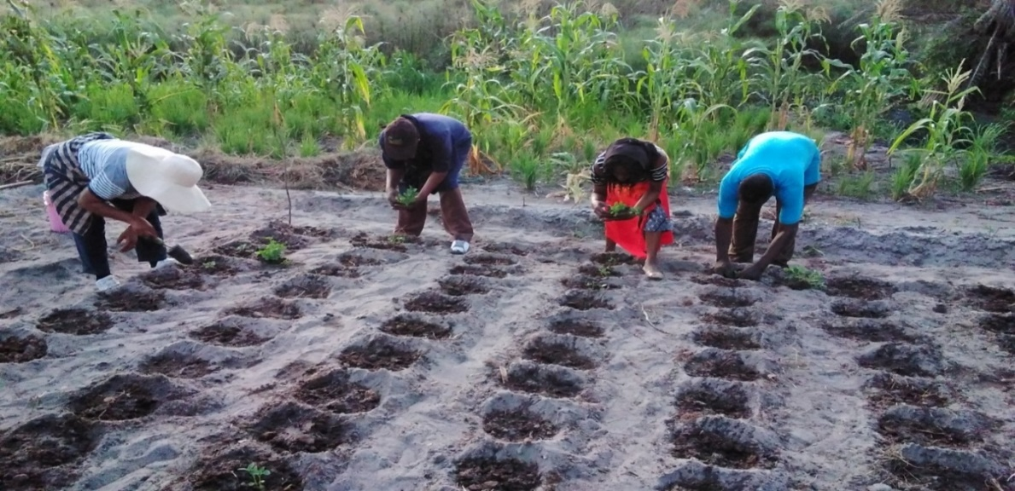
Picture 1: Agronomists from TARI Mikocheni sowing transplanted African nightshade on the demo plots with farmers and Extension Officer at Mwalusembe Village in Mkuranga District.
2.1.2 Demonstration plots established under: Tissue culture-based massive production and unrestricted access to high quality pineapple planting materials project

The unit participate on establishing two demo plots which are One (1) demo plot in Kisambwa Tandai Village at Kinole Ward in Morogoro Municipal and one (1) demo plot in Madeke Village at Mfriga Ward in Njombe District (Picture 2). The aim of these demo plots were to showcase technologies to farmers on improved pineapple variety of MD2 produced by the Centre through tissue culture and Good Agronomic Practices (GPAs) which are proper nursery establishment, spacing and proper management practices.

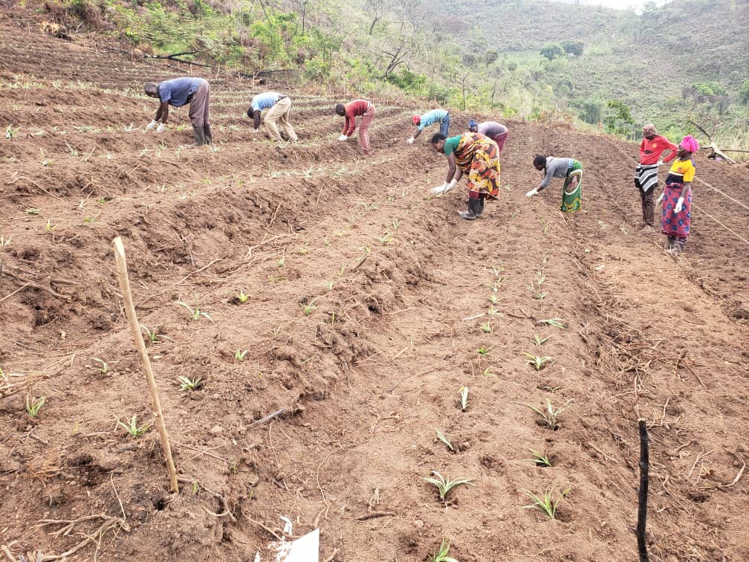

Picture 2:Farmers transplating MD2 pineapple variety in the field at Madeke Village at Mfriga Ward in Njombe District
2.1.6: Demo plots planned, established and technologies disseminated through AgriTecHS
In this quarter the unit has successfully promoted and disseminated developed technologies through agricultural hubs where nine (9) demo plots out of 20 planned demo plots were established in, which eight (8) at FatmaMwasa, Tabora with Coconut intercropped with improved sweet potatoes varieties (X-LUAMBANO and NASPOT-13). The aim was multiplication for distributing them to groups and individual farmer.
One (1) demo plot at Nyakabindi-Shinyanga hub also with coconuts intercropped with maize crop. Other hubs were still maintaining their established demo plots (Table 3)
Table 3: Farmers who visited TARI AgriTecH hubs
AgriTecH Hub | Farmers |  | Total
 | Male | Female
Nzuguni, Dodoma | 39 | 14 | 53
FatmaMwasa, Tabora | 39 | 31 | 70
Mwl. Julius Nyerere, Morogoro | 28 | 8 | 36
Nyakabindi,Shinyanga | 76 | 44 | 120
Total | 182 | 97 | 279

Collecting news (Radio/TV programs aired)
In this quarter the unit has successful aired three (3) Radio and three (3) Video from 3 Farmers field days in Bagamoyo, Ilala and Kigamboni. Aired Radio/TV programs broadcasted on technologies of intercropping coconuts with improved vegetable varieties: Amaranths (Poli, Nguruma and Akeri), a variety of African nightshade (Ambureni) and two African Eggplant (Tengeru white and DB3) varieties, and Good Agronomic Practices (GPAs) including establishment and management of nurseries, spacing, harvesting, post-harvest methods and proper management practices.

2.1.8 Participating in Farmers Field Days(FFDs)
The unit have participated in three Farmer Field Days (FFDs) in two regions Dar es Salaam (Geza Ulole Village in Kigamboni and Pugu Kinyamwezi Farmers Training Centre at Ilala District and Pwani (Kiromo Village at Bagamoyo District. The aim of these FFDs were to showcase new technologies to farmers on intercropping coconuts with improved vegetable varieties: Three improved varieties of Amaranths (Poli, Nguruma and Akeri), One variety of African nightshade (Ambureni) and two varieties of African Eggplant (Tengeru white and DB3) were showcased. Other technologies demonstrated were: Good Agronomic Practices (GPAs) including establishment and management of nurseries, spacing, harvesting, post-harvest methods and proper management practices.
Total number of 134 farmers (61 Males and 73 Females) from Bagamoyo, 72 (31 Males and 41 Females) from Kigamboni, 52 (39 Males and 13 Females) Ilala districts participated. Each of the participants received six packets each of the varieties showcased to plant in their gardens.
2.1.9 Partnership and collaboration established
The institute is expecting to sign memorandum of understanding with two (2) organizations: Tanzania Fertilizer Regulatory Authority (TFRA) to conduct fertilizer verification field trials for vegetables, and Upholding Agriculture Practices (FUAP) to procure TARI expertise for different fields of agriculture to assist during training of farmers.
Also a Danish Manufacturer(Ampliqon) visit the Centre to discuss on how to collaborate in different Agricultural activities taking place at the centre, mainly dealing with distribution of laboratory enzymes and reagents. Furthermore, Ambassadors from SANLAM life Insurance visit the centre to establish the relationship with staffs regarding personal loans from Akiba Commercial Bank(ACB).
Visitors
In this quarter, the institute received a total of 166 farmers (110 Males and 56 Females) in which 37 (29 males and 8 female) visited the centre, 85 farmers (45 Males and 40 Females) visited Chambezi substation and 44 farmers (36 Males and 8 Females) visited Mkuranga substation. Visitors visited the centre to seek agricultural advises through asking different questions concerning management of coconut, pest control in coconut farming and buying of coconut seedlings.

Number of projects documented
In this reporting period a total of 8 projects have been going on. Seven are donor-funded and 1 are government funded projects (Table 4).

Table 4: Total number of projects executed up to 31st December 2022
SN | Project title | Year started | Year ending | Source of funds
1 | Tissue culture-based massive production and unrestricted access of high-quality pineapple planting material | 2022 | 2023 | Govt./Costech
2 | African Cassava Whitefly: Outbreak Causes and Sustainable Solution | 2018 | *2023 | BMGF/NRI
3 | Integrated pest management of Avocado and cucumber pest in East Africa | 2018 | 2022 | ICIPE
5 | Amaranths Amazing | 2022 | 2022/23 | World Veg.

* ACWP-2 has been granted one-year extension

Newsletters and Publication
Nil

Research technical Resources

Table 5. Total number and category of research technical resource
Profession | PhD |  | MSc |  | BSc
 | Male | Female | Male | Female | Male | Female
Agronomy | 1 | 0 | - | 1 | 0 | 0
Plant breeding | 0 | 0 | 1 | 0 | 0 | 0
Entomology | 0 | - | 1 | 1 | - | -
Biotechnology | 0 | 0 | 1 | 0 | 0 | 2
Plant Pathology/Virology | 1 | 1 | 1 | 5 | 1 | 0
Agricultural Engineering | 0 | 0 | 1 | 0 | 1 | 0
Food Science and Nutrition | 0 | 0 | 0 | 0 | 0 | 0
Socio/Agricultural Economics | 0 | 0 | 2 | 1 | 0 | 0
Agricultural Extension and Education | 0 | 0 | 0 | 3 | 0 | 0
Total | 2 | 1 | 7 | 10 | 2 | 2

Human resource capacity building

Long Term-Training
Three (3) students supported by different projects are continuing with their studies in various universities (Table 6). One of them is expected to defend her PhD on 2022.

Table 6: Total number of Researchers in long term training and their status by 31th December 2022
No | Name | Sex | Program | University | Start Date | End Date | Sponsor | Remarks
1 | Vailet Mwaijande | Fe | PhD | Wagengen, Holland | 2015 | 2023 | CIMMTY-TAMASA/BMGF | Graduating April 2023
2 | Evangelista Chiunga | Fe | PhD | NCSU-USA | 2017 | 2023 | BMGF/NCSU | Writing thesis in TZ
3 | Emmanuel Mrema | Fe | PhD | Accra-Ghana | 2019 | 2024 | BMGF/Next Gen. | Doing research work in TZ
 | Total | 3

Research Infrastructure
In this reporting period, the GMO testing laboratory has received equipment and reagents for GMO testing worth Tshs. 356,384,496.89 procured by the government to strengthen the laboratory services. At present about 95% of the ordered goods have been received. In Lot No. 1 three (3) of the 14 ordered items yet to be delivered, Lot No.2 completed 100% delivered, and Lot No. 3 seven 7 of 35 items ordered yet to be delivered.
  - Funding
In this reporting period TARI-MKN received funds from two main sources: government as operation charges (OC) amounting to Tshs. 14,637,195.00 and from donors amounting Tshs. 33, 303,106.63 (Table 6). The available funds were utilized primarily on research activities and normal operations.

Table 6. Total funds received (Tshs.), their sources and expenditure for the period ending 31th September 2022
OC | *Donor | Govt./Res. | Sales | Com. Levies
1,637,195.00 | 33,303,106.00 | 0.00 | 8,908,410.00 | 00.00

*IUSD-2300Tshs.

Seed Produced (in Kgs) including cuttings
Of the Tshs. 8,908,410.00 generated in this reporting period from the selling of high-quality coconut seedlings

Table 9. Total amount of seed/seedlings produced and sold by 31th December 2022
Product | Categories | Quantity sold | Price per unit | Total amount realised (TZS)
Coconut | Seedlings | 3,563 | 2,500 | 8,908,410.00
Grand total |  |  |  | 8,908,410.00

Monitoring and Evaluation
In this reporting period, no monitoring and evaluation exercise was conducted due to COVID 19 pandemic, there was restricted movement.

Annexes (2022)
Annex 1a: TARI-Mikocheni Researchers Status by Highest Qualifications
Zones | Station | Highest qualification |  |  | Total
 |  | BSc | MSc | PhD
Eastern | TARI-Mikocheni | 7 | 17 | 3 | 27
Annex 1b: TARI Field Officers and Support Staff
Zones | Field officers | Support staffs
TARI-Mikocheni | 12 | 12
Annex 2: Recruited Researchers
SN | Name | Gender | Designation | Station
1 | Stella Joseph Ayanga | Female | AO-1I | TARI-Mikocheni
2 | Fauzia Khalid Mpiganzila | Female | AO II | Chambezi
3 | Generoza Lauto Tizanga | Female | AFO II | Mkuranga
Annex 3a: Researchers Employed on Contracts and retired
SN | Name | Gender | Highest Degree | Discipline | Status | Project
1 | Zuberi Seguni | Male | PhD | Entomology | End of Service | ACWP-2
2 | Leonia Mlaki | Female | BSc | Agric. | End of Service | ACWP-2
3 | Stanley Geoffrey | Male | MSc | Agric. | Retired | ACWP-2
4 | Thomas Mrosso | Male | BSc | Forestry | End of Service | ACWP-2
5 | Ezekiel Ndilanhna | Male | BSc | Driver | Retired | ACWP-2
6 | Revocatus Mugisha | Male | BSc | Driver | End of Service | ACWP-2

Annex 3b: List of Researchers on Leave without Pay by Station
S/N | Name | Gender | Higher Degree | Discipline | Station | Current Affiliation
 | Nil | - | - | - | - | -

Annex 4a: Researchers on Long-Term Training for the period by December 2022
SN | Name | Sex | Univ. | Station | Degree/ Discipline | Year of Study | Sponsor
1 | Ms. Vailet Mwaijande | Fe | Wagengen-Holland | TARI-MKN | PhD | 2015 | CIMMTY/BMGF
2 | Mr. Emmanuel Mrema | Ma | Accra-Ghana | TARI-MKN | PhD | 2018 | NextGen.
3 | Ms. Evangelista Chiunga | Fe | JKUAT-Kenya | TARI-MKN | PhD | 2018 | BMGF/NCSU

Annex 4b: Support Staff on Long-term Training for the period by December 2022
S/N | Name | Sex | Research Station | Degree and Discipline | Sponsor | Amount of money | Year of Study
1. | NIL | - | - | - | - | - | -

Annex 5: Short-term Training for Staff
SN | Course Title | Staff Category | Number of Participants | Duration | Year of Study | Sponsor
1 | Taneps | PMU officer | 1 | 7 days | Nov.2022 | TARI-HQ

