TANZANIA AGRICULTURAL RESEARCH INSTITUTE

Monthly Progress Report from 1st–30thAPRIL 2023

Technology Transfer and Partnership-TARI Mikocheni

Prepared by:

Vidah Y. Mahava

Coordinator for Technology Transfer and Partnership TARI Mikocheni

30th APRIL 2023

1.0 Introduction
Tanzania Agricultural Research Institute-(TARI-Mikocheni) is one of the 17 research centres under TARI.TARI-Mikocheni mandate is in two-folds, namely conduct and promote research for the development of the coconut sub-sector and promote research and utilization of agricultural biotechnology for socio-economic development in the country.
The centre’s head office is in Dar es Salaam at Mikocheni B, Plot 22 along the Coca Cola Road. It has two sub-stations, namely Chambezi and Mkuranga, where most of the research activities are conducted. The former is located about 55 KM North of Dar es Salaam near Bagamoyo town at latitude S6.52⁰ and longitude E 38.91⁰, while Mkuranga sub-station is located at S 7.12⁰ and Longitude E 39.20⁰, about 50 KM South of Dar es Salaam.
There are two departments: 1) Research and Innovation and 2) Technology Transfer and Partnership. Under these departments there are six subprograms: Crop Research, Natural Resources, Post-harvest Management, Socio-economics and Marketing; Technology Dissemination, Commercialization and Partnership; and Knowledge Management and Communication Programs.
The Mikocheni centre basically has two research programs, which its mandates are: Coconut and Biotechnology. The coconut program is the main with four (4) research units which include: Agronomy, Disease & Pest Control, Socio-economics, Post-harvest and Technology Transfer; the Biotechnology Program accommodate three (3) units Tissue Culture, Molecular Diagnostics and Genetic Engineering Laboratories. All the research activities in each unit in the coconut program are designed to address all agricultural challenges facing the coconut agro-ecologicalsystems which include poor coconut husbandry practices, effect of drought stress, poor soil fertility, incidence and severity of noxious pests, high incidence and damage by the coconut Lethal Disease and planting of low yielding varieties. Other challenges are low expansion, low level of rehabilitation of the area under coconuts, limited value addition/processing and poor marketing. Biotechnology in the centre acts as a tool cut across all crops and supports other research mandate.
- Technology Dissemination pathways used by TARI
Various pathways were used for dissemination of agricultural technologies from research to different stakeholders which includes demonstration plots and the use of hubs (AgriTeCH).
2.1: Technologies disseminated through AgriTecHs
Three (3) demo plots at Mwalimu Julius Nyerere-Morogoro one (1) demoplot on Banana tissue culture in which Black turtile beans will be intercropped on May 2023 as as a cover/leguminous crop and one (1) Coconuts intercropped with mangoes and oranges in which Pigeon pea will be intercropped on May 2023 as leguminous crop and (3) demoplot already established but not yet planted the aim will be to showcase technologies to farmers on intercropping coconuts with improved vegetables varieties of Amaranthus (Poli, Nguruma and Akeri), One variety of African nightshade (Ambureni) and two varieties of African Eggplant (Tengeru white and DB3),nursery management and Good Agronomic practices(GAPs).
One (1) demo plot at Nzuguni-Dodoma coconuts are intercropped with cowpea,(1) one demoplot at FatmaMwasa-Tabora where Coconuts are intercropped with improved sweet potatoes varieties(X-LUAMBANO and NASPOT-13) for Slips/cuttings multiplication for the aim of distributing them to groups and individual farmers, One(1)demo plot at Nyakabindi-Shinyanga hub with coconuts only in preparation of intercropping beans ,
Table 1: Technologies disseminated by TARI through AgriTecH(s)
AgriTecH | Crop | Variety/technology disseminated
FatmaMwasa, Tabora | 1. Coconuts and sweet potatoes | Coconuts intercropping improved sweet potatoes(X-LUAMBANO and NASPOTI-13)
 |  | Ridge formation to create good drainage and root expanding areas for smooth sweet potatoes growth
 | Total No. technologies disseminated | 2
Nzuguni,Dodoma | 1.Coconuts,cowpea | Coconuts intercropped with cowpea
 | Total No. technologies disseminated | 1
Mwl. Julius Nyerere,Morogoro | 1.Banana tissue culture | Clean banana tissue culture plants
 | 2.Coconuts, Mangoes,Oranges | Intercropping with fruit tree crops
 | 3.Amaranthus,African nightshade and African Eggplant | Coconuts intercropped with improved vegetables
 | Total No. technologies disseminate | 3
Nyakabindi,Shinyanga | 1.Coconuts | Coconuts(East African Tall)
 |  | Pest control using cultural method through cleaning the fields to remove breeding sites
 | Total No. technologies disseminated | 2
TOTAL | Total No. technologies disseminated | 8
2.1.1: Disseminated planting materials through AgriTecHub(s)
Total number of 300 coconut seedlings were planned to be disseminated and planted at Mwl. J.K.Nyerere hub.The coconut seedlings variety of East African Tall nursery seedlings were established in this April 2023.
Table 2: Dissemination of planting materials through AgriTecH(s) by TARI
Name of Agri.TecH | Type of planting material | Crops Varieties | No. Planned Propagated planting materials | No. of Disseminated planting materials
Mwl. Julius Nyerere, Morogoro | Seedlings | East African Tall | 300 | 300
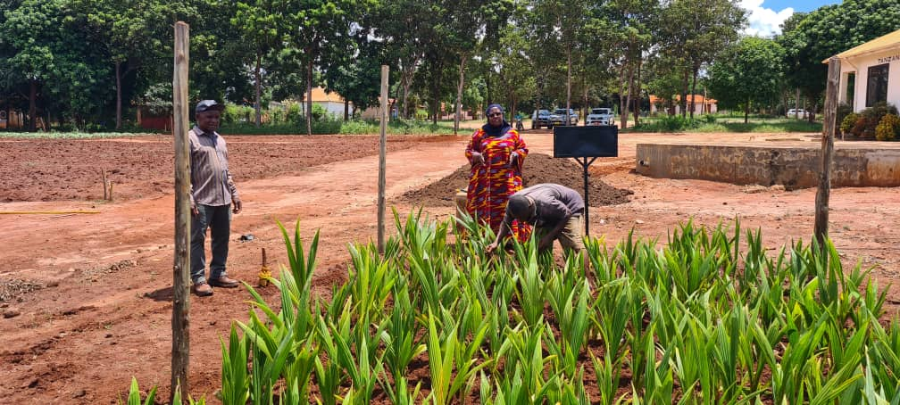
Picture 1:Ms.Vidah Mahava,Technology Transfer Coordinator at TARI Mikocheni(standing right) and Mr.Kwicho Hizza,Chambezi substation manager(standing left) supervising nursery establishment activities in Mwl.J.K.Nyerere hub in Morogoro. 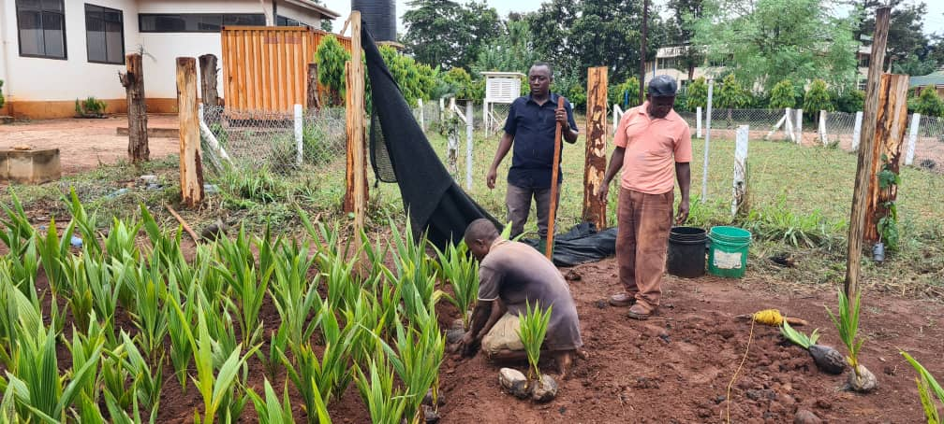Picture 2:Mr.Kwicho Hizza(Chambezi Substation Manager) supervising planting of coconut seedlings at Mwl J.K.Nyerere hub in Morogoro. 2.4.Stakeholders reached with improved technologies disseminated by TARIMikocheni
Total number of 69 farmers (47 males and 22 females) in which 40 farmers( 22males and 18 females) visited Chambezi sub-station and 29 farmers (25 males and 4 females) visited Mkuranga sub-station in April 2023 request on buying coconut seedlings,asking different questions concerning management of coconuts and pest control in coconut farming.

Table 3: Stakeholders reached with Technologies Disseminated from TARI Mikocheni Centre to various places
Place |  | Stakeholders | Technologies disseminated
Chambezi | 40 Farmers ( 22 Males and 18 Females) |  |  | 1. Coconuts intercropped with mangoes and orange to control pests through weaver ants which feed on coreid bugs.  2. Mechanical remover of beetles using hook.  3. Cultural control by cleaning field removing dead logs which are breeding site for beetles.  4. Using of Traps (Pheromones,PVC Pipe and Tin) to trap beetles.
Mkuranga | 29 Farmers (25Males and 4 Females) |  |  | 1. Coconuts intercropped with mangoes and orange to control pests through weaver ants which feed on coreid bugs.  2. Mechanical remover of beetles using hook.  3. Cultural control by cleaning field removing dead logs which are breeding site for beetles.  4.Using of Traps(Pheromones,PVC Pipe and Tin) to trap beetles  5. Coconutsintercropped with Improved vegetables varieties Amaranth(Nguruma,Poli and Akeri),Africannightshade (Ambureni) and African eggplant (DB3 and Tengeru white).
Total number of technologies disseminated |  |  |  | 5
3. Knowledge Management and communication
3.1 TARI Website Content management
Different information was uploaded to TARI website as shown by the table below:
Table 4: Type and numbers of information uploaded to TARI website for April 2023
Centre | Type of information uploaded | Number/frequency | Remarks/any feedback | Challenges
TARI – Mikocheni | News | 0 | - | Lack of facilities including Internet, Computer, Scanner, Photocopy machine and Mobile phone
 | Publications | 1
 | Images/photos | 0
 | Videos | 4

3.2 Information education and communication materials
Planned number of materials to be disseminated in April 2023 were 100 leaflets on coconut and tissue culture where 25 leaflets were managed to be disseminated.

Table 5: Information materials produced and distributed
Centre | Number of print communication materials
 | Posters | signboards | Fliers | brochures | Banners | Wheel covers | Leaflets | Others specify
TARI – Mikocheni | - | - | - | - | - | - | 25 | -

4 TARI Visibility
4.1 Signboards: Nil
Preparation of signboards: areas fixed with signboards with uniform format and design across TARI Centres
4.2 Mass media prepared by TARI Mikocheni in April 2023
In this reporting period Mass Media planned to air 2 TV while aired 2 TV. Also planned Radio were 3 while aired 0 radio, also Planned 3 newspapers actual released were 0 also Planned Social Media were 30 while aired Social Media were 15 as shown on the table 6 below.

Table 6: Number of TVs, radio, newspapers and social media produced and disseminated
Centre | Numbers prepared/hired/made/received
TARI – Mikocheni | TV | Radio | Newspapers | Social media | Short Messages | Phone calls | Others specify
 | 2 | 0 | 0 | 15 | 37 | 32 | -
5.0 Strengthening Partnerships and Collaboration
5.1 Meetings/ conferences/ symposia/ workshops
One researcher(Male) from Biotechnology attended one day meeting on 26th April, 2023 at Chambezi Substation(Bagamoyo) in which the aim was to discuss on long term land disputes and finding the solutions to the conflicts arised.Two researchers (2Males) from Biotechnology and Social Economic Units attended the meeting held at Saint Gaspar Conference Centre in Dodoma on 28th April where the main objective was to discuss on different matters pertaining TARI workers performances.

Table 7: Meetings/conferences/symposia/workshops conducted/attended by TARI staffs
No | Tittle/themes | Dates | Venue | Partners | Type of event(workshop/Meeting
1. | Solving land disputes in Chambezi substation | 26th April 2023 | Chambezi substation | Ministry of Agriculture, TARI HQ,TARI Mikocheni,LGA’S | Meeting
2. | TARI Main Workers Council | 28th April 2023 | Saint Gaspar Conference Centre | All TARI Centres Representatives,TUGHE and RAAWU. | Meeting
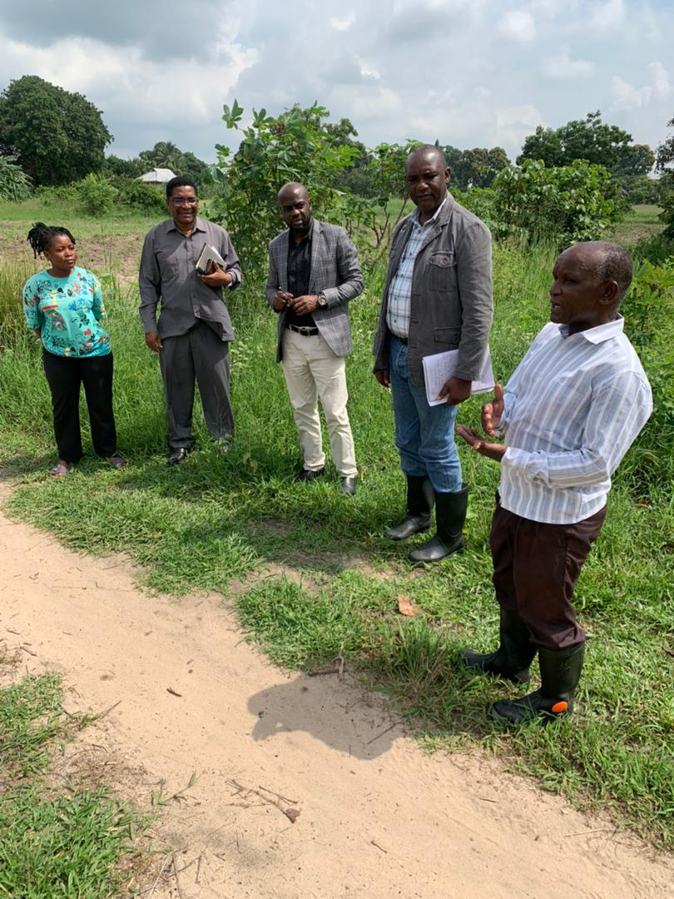
Picture 3: Dk.Hussein Mohamed Omar(Deputy Sekretary General from Ministiry of Agriculture,at the center),General Director of TARI,Dk.Geoffrey Mkamilo(second from left),TARI Mikocheni centre Manager,Dk.Fred Tairo(fourth from left) and Ms.Faudhia Khalid,Agricultural Officer(first left) listening to Chambezi Farm Manager,Mr.Kwicho Hizza(first right) during the visit on solving land disputes at Chambezi Substationin Bagamoyo. 5.2.Visitations
Total number of 14 farmers (10 Males and 4 Females) stakeholders visited the centre for different purposes this April 2023 as shown in table 8 below.
Table 8: Visitorsvisited Mikochenicentre
S/No | Date of the visit | Type of visitors | Total number | Aim of the visit
 | 3rd April 2023 | Individual farmer from Lindi | 1 Male | He wanted to get information on coconut production
 | 4th April 2023 | Individual farmer from Iringa | 1 Male | He wanted information on banana and lemon production
 | 5th April 2023 | Centre Manager from TARI Mlingano | 1 Female | She wanted to visit Tissue culture laboratory to see progress on sisal production activities
 | 11th April 2023 | A farmer from Da es salaam | 1 Male | He wanted to get information on overall farming education especially in oilpalm and annual crops i.e.maize,beans.
 | 18th April 2023 | A farmer from Dares salaam | 1 Male | He wanted to get information on coconut production
 | 19th April 2023 | Scientists from India ambassodors | 2 Males | They wanted to get soil analysis of their carried soil sample
 | 20th April 2023 | Farmers from Dar es salaam | 2 Females | They wanted to get coconut education and seedlings for coconut farming
 | 21st April 2023 | Scientist from TFRA | 1 Male | He wanted to get information on fertilizer in collaboration with Agronomy Department
 | 24th April 2023 | Farmers from Dar es salaam | 2 Males | They wanted to get information and buying coconuts seedlings,oranges,mangoes production and education on coconut pests.
 | 28th April 2023 | Agricultural officers from Kisarawe | 2(1 Male and 1Female) | They wanted to get coconut seedlings for coconut plantation

5.3. Challenges
- Lack of working equipment to farm guards at TARI Mikocheni sub-stations (Chambezi and Mkuranga) ,i.e.,Raincoats,gumboots and defensive weapon against invaders.
- Lack of farming equipment i.e. tractors for clearing and tillage in coconuts plantations
- Coconuts thieves due to surrounded bushes and shortage of farm guards at Chambezi and Mkuranga sub-stations
- Limited funds for TTP activities at the centre which hinder publications of updated news and scientific findings and development of dissemination materials like brochures, leaflets, banners, posters, calendars etc.
5.4.Conclusion and Recommendations
- Working equipment to farm guards should be provided to increase their efficiency and salary should be paid on time to meet the demands of the labourers.
- Modern tractors should be provided for land clearing in order to reduce bushes which reduce productivity, hibernate thieves and wild animals.
- Adequate farm guards should be hired to ensure maximum security, especially at Chambezi and Mkuranga sub-stations where coconut production is higher.
- Funds should be provided for TTP activities at the centre.

