TANZANIA AGRICULTURAL RESEARCH INSTITUTE

1st Quarter Progress Report from 1st July to 30th September 2023

Technology Transfer and Partnership

Prepared by:

Vidah Y. Mahava

Coordinator for Technology Transfer and Partnership TARI Mikocheni

30th SEPTEMBER 2023

1.0 Introduction
Tanzania Agricultural Research Institute-(TARI-Mikocheni) is one of the 17 research centres under TARI.TARI-Mikocheni mandate is in two-folds, namely conduct and promote research for the development of the coconut sub-sector and promote research and utilization of agricultural biotechnology for socio-economic development in the country.
The centre’s head office is in Dar es Salaam at Mikocheni B, Plot 22 along the Coca Cola Road. It has two sub-stations, namely Chambezi and Mkuranga, where most of the research activities are conducted. The former is located about 55 KM North of Dar es Salaam near Bagamoyo town at latitude S6.52⁰ and longitude E 38.91⁰, while Mkuranga sub-station is located at S 7.12⁰ and Longitude E 39.20⁰, about 50 KM South of Dar es Salaam.
There are two departments: 1) Research and Innovation and 2) Technology Transfer and Partnership. Under these departments there are six subprograms: Crop Research, Natural Resources, Post-harvest Management, Socio-economics and Marketing; Technology Dissemination, Commercialization and Partnership; and Knowledge Management and Communication Programs.
The Mikocheni Centre basically has two research programs, which its mandates are: Coconut and Biotechnology. The coconut program is the main with four (4) research units which include: Agronomy, Disease & Pest Control, Socio-economics, Post-harvest and Technology Transfer; the Biotechnology Program accommodate three (3) units Tissue Culture, Molecular Diagnostics and Genetic Engineering Laboratories. All the research activities in each unit in the coconut program are designed to address all agricultural challenges facing the coconut agro-ecological systems which include poor coconut husbandry practices, effect of drought stress, poor soil fertility, incidence and severity of noxious pests, high incidence and damage by the coconut Lethal Disease and planting of low yielding varieties. Other challenges are low expansion, low level of rehabilitation of the area under coconuts, limited value addition/processing and poor marketing. Biotechnology in the centre acts as a tool cut across all crops and supports other research mandates.
- Technology Dissemination pathways used by TARI
Various pathways were used for dissemination of agricultural technologies from research to different stakeholders which includes demonstration plots, Field Days and the use of hubs (AgriTeCH).

2.1: Technologies disseminated through AgriTecH(s)
In this reporting time AgriTechs hubs continue to disseminate their usual technologies as follow: At Mwl Julius Nyerere eight (8) technologies were disseminated in which (1) demo plot on Banana tissue culture intercropped with black turtle beans as a cover/leguminous crops, (2) demo plot where Coconuts are intercropped with mangoes, oranges and black turtle beans,(3)demo plot planted with two varieties of African nightshade which are DB3 and Tengeru white and (4) demo plot planted with two varieties of African nightshade seedlings of Ngurumo and Olevolosi and (5)demo plot planted Amaranths(Poli, Nguruma and Akeri) to showcase technologies on improved vegetables and Good Agronomic practices(GAPs).
One (1) demo plot at Nzuguni-Dodoma with Coconuts only, failure to intercrop with other crops due to lack of rainfall, (1) one demo plot at Fatma Mwasa-Tabora with Coconuts and One (1) demo plot at Nyakabindi-Shinyanga hub with coconuts only.

Table 1: Technologies disseminated by TARI through AgriTecH(s)
AgriTecH | Crop | Variety/technology disseminated
Fatma Mwasa, Tabora | 1. Coconuts | Coconuts (East African Tall)
 | Total No. technologies disseminated | 1
Nzuguni, Dodoma | 1.Coconut | Coconuts (East African Tall)
 | Total No. technologies disseminated | 1
Mwl. Julius Nyerere, Morogoro | 1.Banana tissue culture and black turtle beans | Intercropping banana with leguminous crop
 | 2.Coconuts, Mangoes, Oranges, and black turtle beans | Intercropping with fruit tree crops and leguminous crop
 | 3.Improved vegetables varieties | African eggplants (DB3 and Tengeru white),African nightshade(Ambureni) and Amaranths(Poli, Nguruma and Akeri)
 | Total No. technologies disseminate | 6
Nyakabindi, Shinyanga | 1.Coconuts | Coconuts(East African Tall)
 | Total No. technologies disseminated | 1
TOTAL | Total No. technologies disseminated | 9

2.2. Stakeholders reached with improved technologies disseminated by TARI Mikocheni
2.2.1 Stakeholders reached during Saba Saba Exhibitions at Mwl.J.K.Nyerere grounds
TARI Mikocheni participated during sabasaba exhibition at Mwl.J.K.Nyerere fair trade grounds for 16 consecutive days starting from 28th July to 13th July 2023.Stakeholders reached by the TARI Mikocheni centre during Saba Saba exhibitions, were 4358 stakeholders in which 2924 were males and 1434 were females).The centre exhibit technologies of different crops, added value products and services provided by Tanzania Agricultural Research Institute (TARI).

Number of technologies and products disseminated during Saba Saba exhibitions are shown in table 2 below:
Table 2: Displays made by TARI Mikocheni
Display | Number/Quantity | Type of Technology
Technologies | 7 | Good coconut varieties (EAT)
 | 21 | Good sisal varieties(H.11064)
 | 6 | Good cassava varieties (Kamsweke and Mkombozi)
 | 18 | Good pineapple varieties (MD2 and Kiwangwa/Mpingo)
 | 100 | Cuttings of sweet potatoes (Jewel)
 | 3 | Using of pheromones chemicals to trap male fruit fly in mangoes
 | 1 | Herbarium with Rhinoceros beetles(chonga) which destroy coconut tree
 | 6 | Improved vegetables varieties of African eggplants (DB3 and Tengeru white), African nightshade (Ngurumo and Olevolosi), and Amaranths (Akeri and Nguruma)
 | 10 | Good mangoes varieties (Tom, Kent, Dodo, Apple, and Alphonso)
 | 1 | Coconut pest control using hook
Products | 30 | Virgin Coconut Oil (VCO)
 | 20 | Sweet potatoes chips and crisps containers
Laboratory Equipment | 1 | Amplifying of DNA sequences on plant/crop(genotyping) using Polymerase Chain Reaction(PCR) Machine
 | 1 | Separating of particles suspended in a liquid of crop sample using Centrifuge machine

The following are the pictures taken during Saba Saba exhibitions at Mwl.J.K.Nyerere grounds
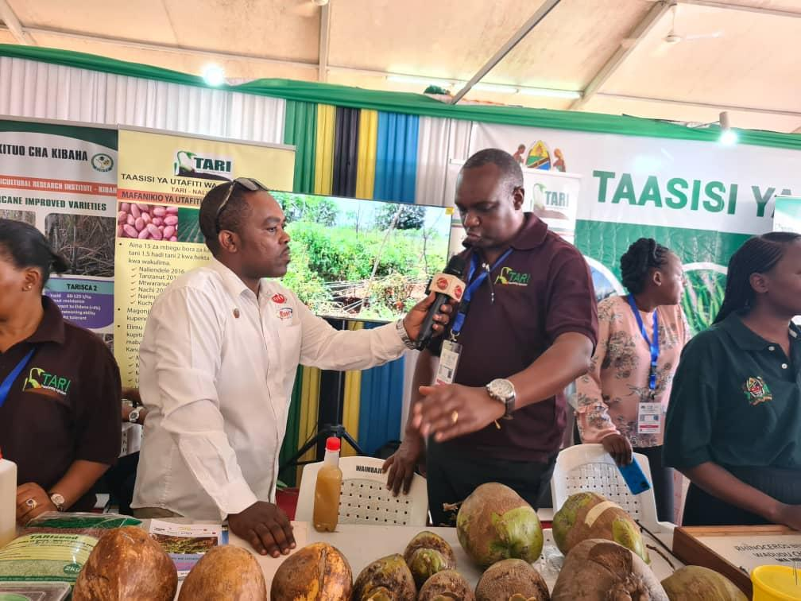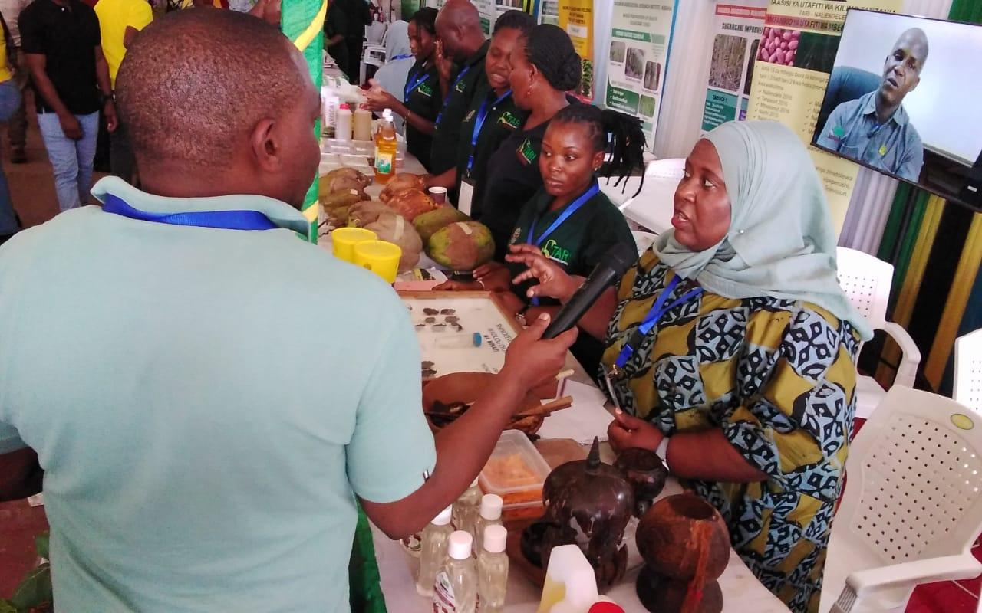Picture 1:(Left side)Dr.Fred Tairo, Centre Manager explaining to Channel Ten broadcasting reporter and other stakeholders on seen in the picture on different technologies disseminated at TARI Mikocheni,(right side),Ms.Vidah Mahava, Centre Coordinator of Technology Transfer and Partnerships elaborating to TBC Broadcasting Reporter on two mandate of TARI Mikocheni in providing services to agricultural stakeholders
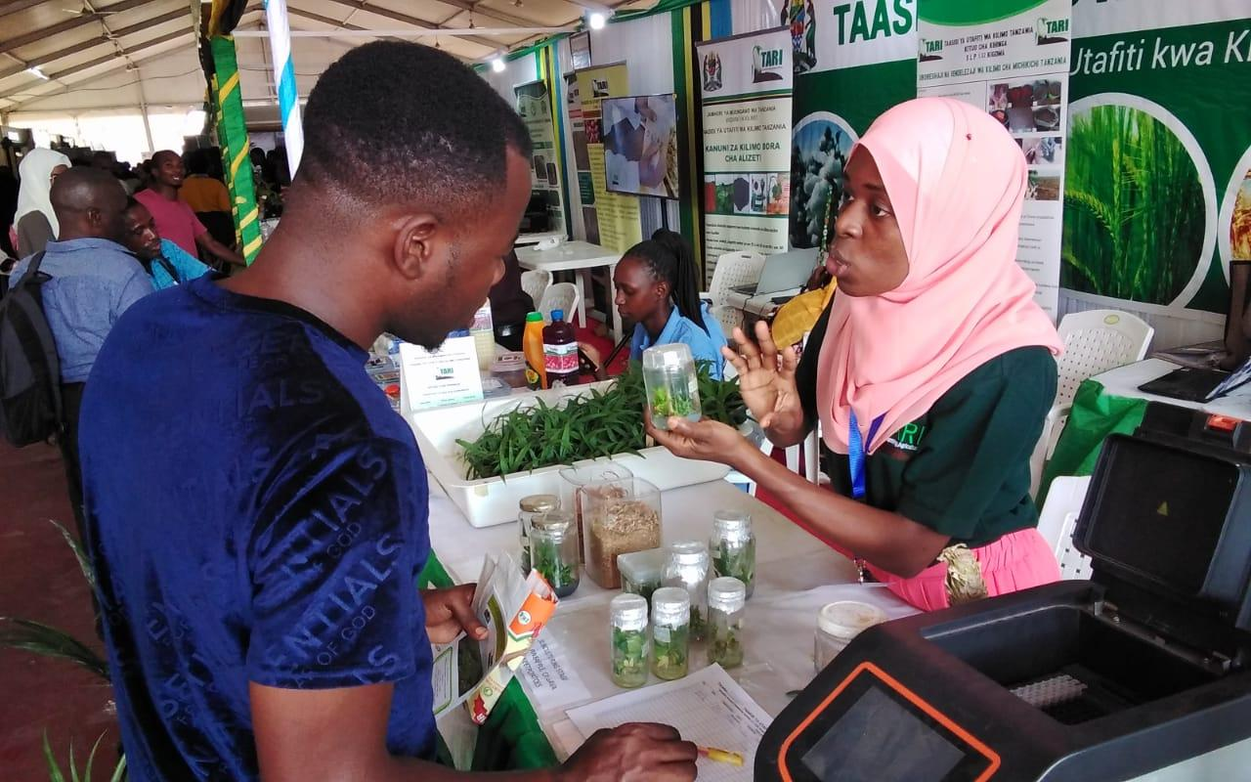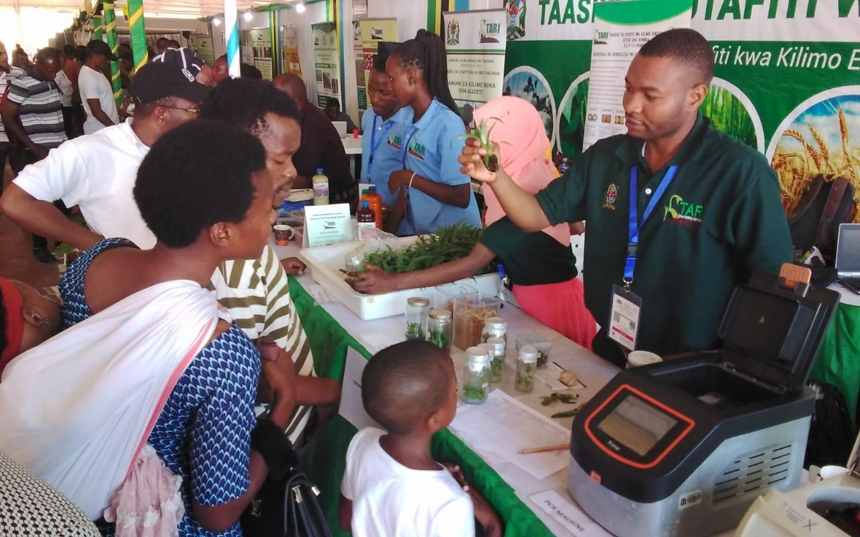Picture 2:Ms.Rahma Mkangwa explaining on the benefits of using Tissue Culture for multiplying sisal seedlings, (right side) Mr. Jackson Rashid explaining to farmers the use of media in propagating pineapple seedlings at the tissue culture laboratory
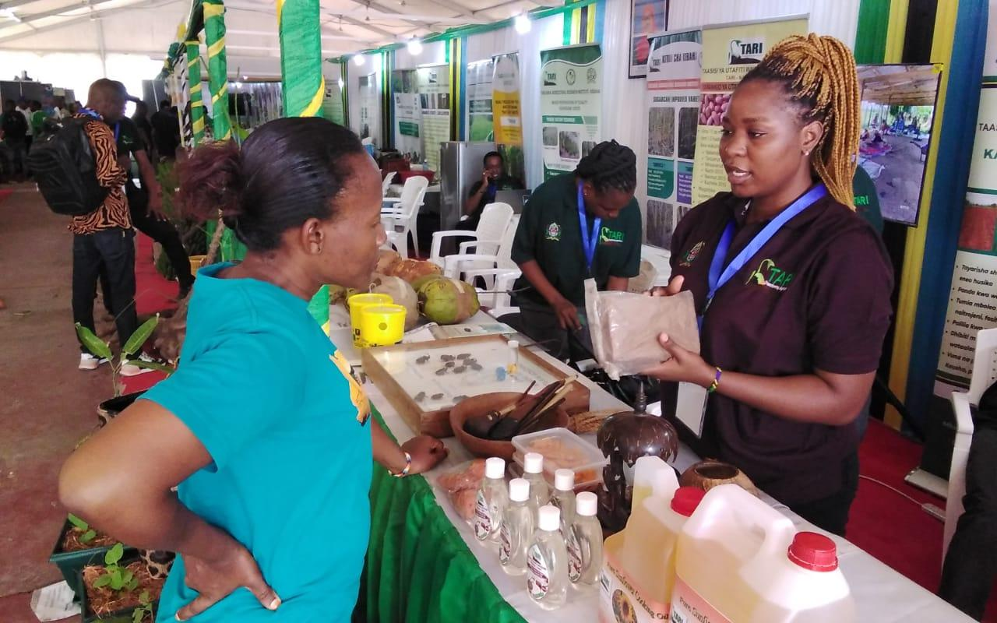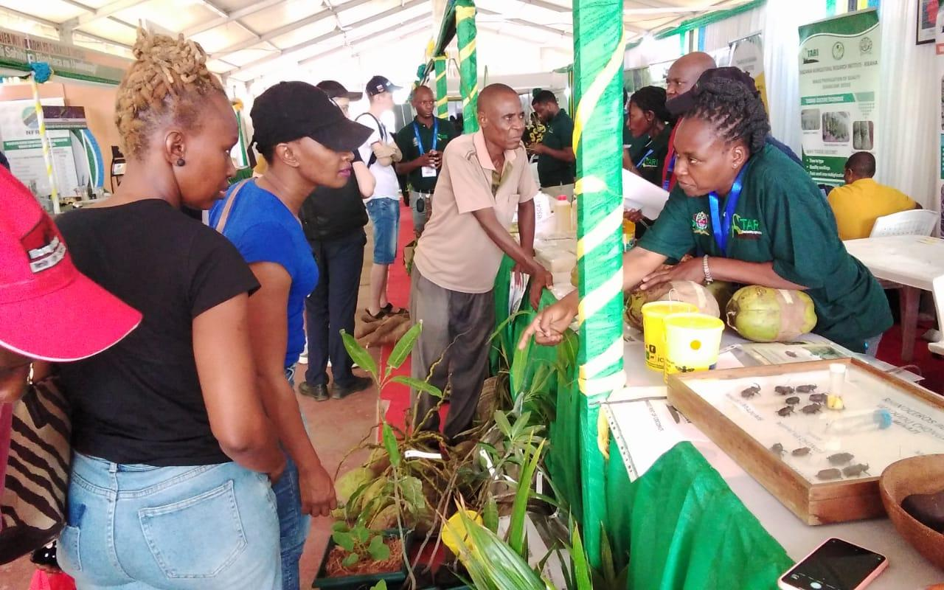
Picture 3: Ms. Suzana Theonest explaining on the use of coconut by products including virgin coconut oil, coconut husk and some decoration furniture’s from coconut tree,(right side)Ms.Violeth Mwaijande elaborating on importance of using improved vegetable varieties in increasing product and production
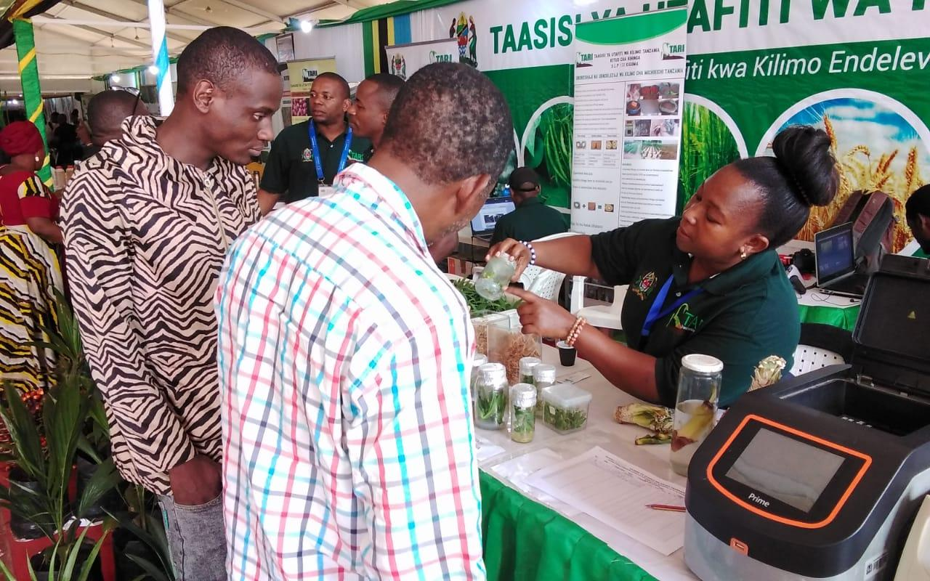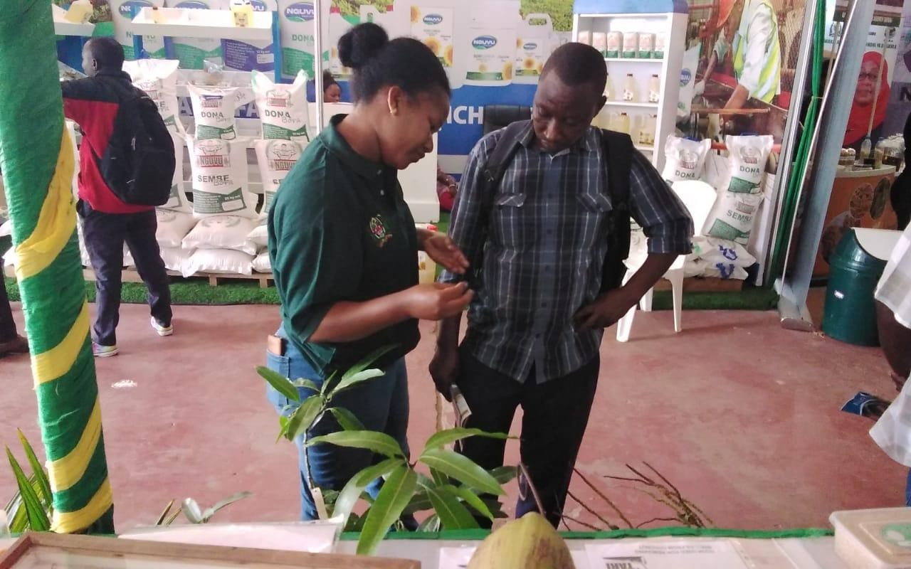Picture 4: Ms.Magreth Lupembe explaining on how cassava seedlings are propagated in growth media before transferred to nursery, (right side) Ms. Happiness Mbaruku explaining to farmer on how to manage fruit flies in mangoes using pheromones traps
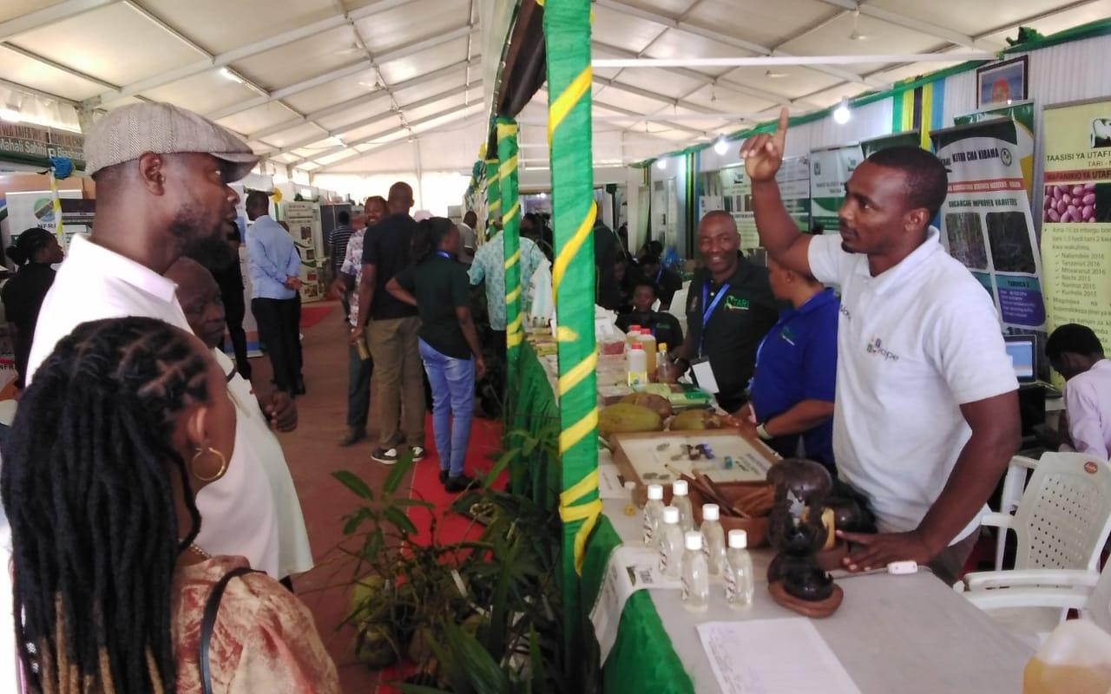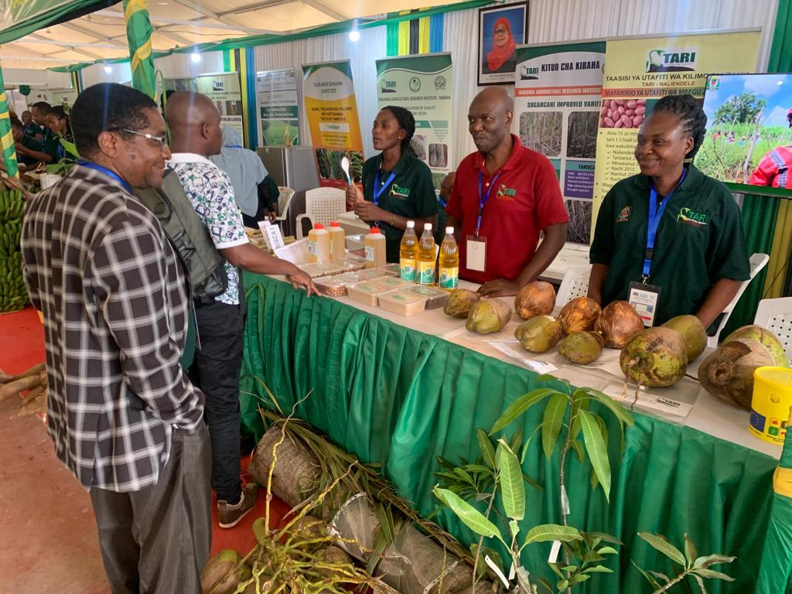
Picture 5: Mr. Essau Elosojuki explaining on how to control Rhinoceros beetle (Chonga) on coconut farming, (right side) Dr.Geofrey Mkamilo, the General Director of TARI speaking to the researchers during Saba Saba exhibitions at Mwl. J.K. Nyerere grounds in Dar es Salaam
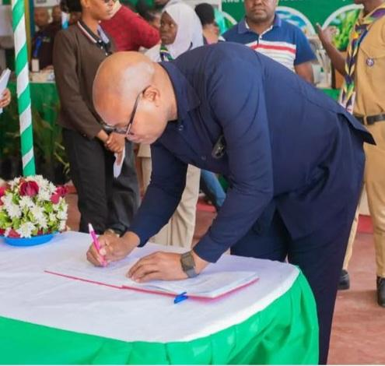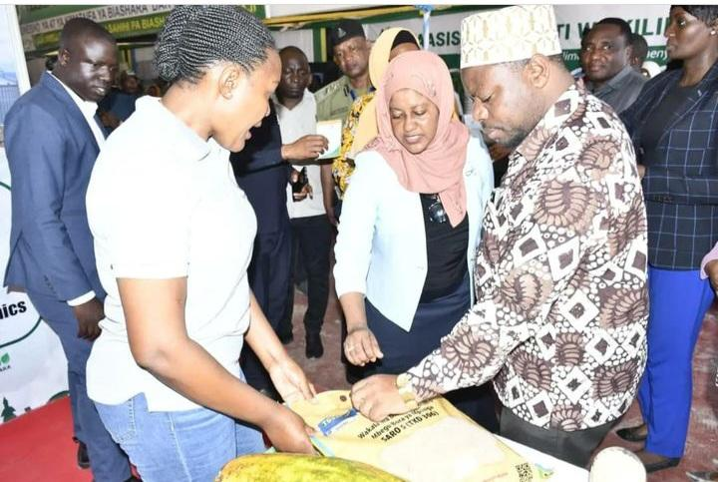
Picture 6:(Left side)Namibia Ambassador in Tanzania,Hon. Lebbius Tangeni, the signing on visitors book,(right side)Regional Commissioner of Dar es Salaam, Hon.Albert Chalamila, the Region being oriented on packages of crops from agricultural expert.

2.2.2 Stakeholders reached during Nanenane Exhibitions at John Mwakangale and Mwl.J.K.Nyerere grounds
Total number of 7996 stakeholders were reached by TARI Mikocheni Centre technologies in which 5016 stakeholders (2814 Males and 2292 Females) visited TARI Pavilion at John Mwakangale grounds in Mbeya and 2890 stakeholders (1742 Males and 1148 Females) visited TARI Pavilion at Mwl.J.K.Nyerere grounds in Morogoro. The Centre exhibited technologies of different crops, added value products and services provided by Tanzania Agricultural Research Institute (TARI).

Number of technologies and products disseminated are shown in table 3 below:
Table 3: Displays of technologies made by TARI Mikocheni at John Mwakangale in Mbeya and Mwl.J.K.Nyerere grounds in Morogoro
Categories | Technologies
Coconut | - Coconut varieties of East African Tall(EAT)
 | - Intercropping of coconut with Mango, Oranges, lemons and leguminous crops
 | - Improved vegetables varieties of African eggplants(DB3 and Tengeru white),African nightshade(Ngurumo and Olevolosi) and Amaranths(Poli, Nguruma ,Akeri, Madira 1 and Madira 2)
 | - Pest control in coconuts using hook in combating Rhinocerous beetle and weaver ants to combat coconut mites and bugs)
 | - Postharvest coconut products – Virgin Coconut Oil, planting medium from coconut husks, briefcase, decorations, basket, flower pot, candles and lamp supporter
Biotechnology | - Using genetics technology in:  - Identifying vector of diseases in crops  - Identifying high quality crop varieties  - Multiplying free from diseases tissue culture propagated crops  - Using Tissue Culture technologies in multiplication of crops plants such as pineapples, cassava, sweet potatoes, sisal and banana

The following are pictures taken during Nane Nane Exhibitions at John Mwakangale grounds in Mbeya:
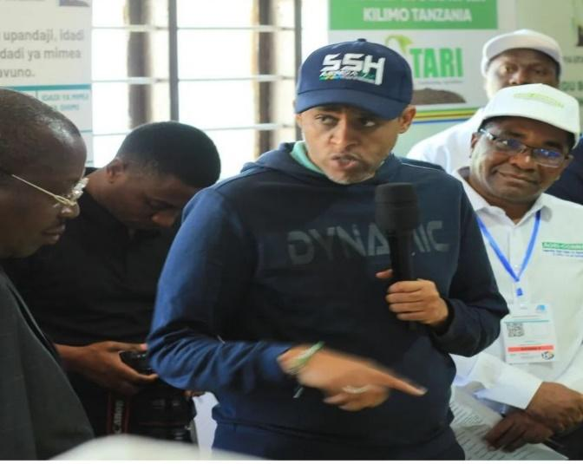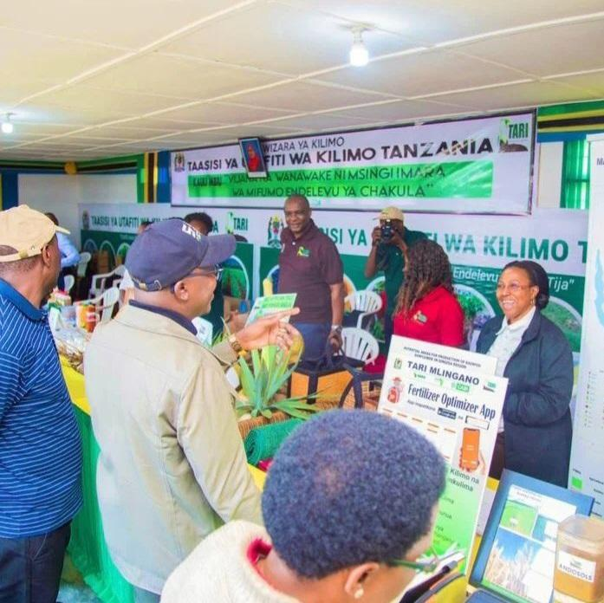
Picture 7:(Left side) Deputy President of United Republic of Tanzania, Dr.Philip Mpango listening to Minister of Agriculture, Hon.Hussen Bashe and Director General of TARI Dr.Geoffrey Mkamilo elaborating on research activities performed by TARI,(right side)Deputy Minister of Agriculture,Hon.Anthony Mavunde (with black cap) inspecting TARI Pavilion at John Mwakangale grounds in Mbeya

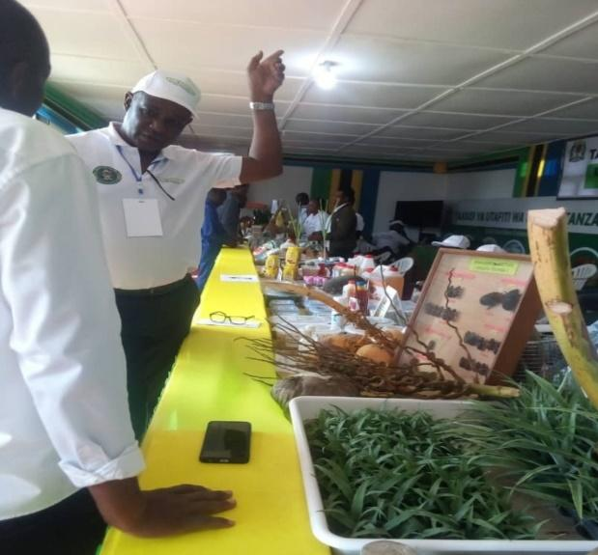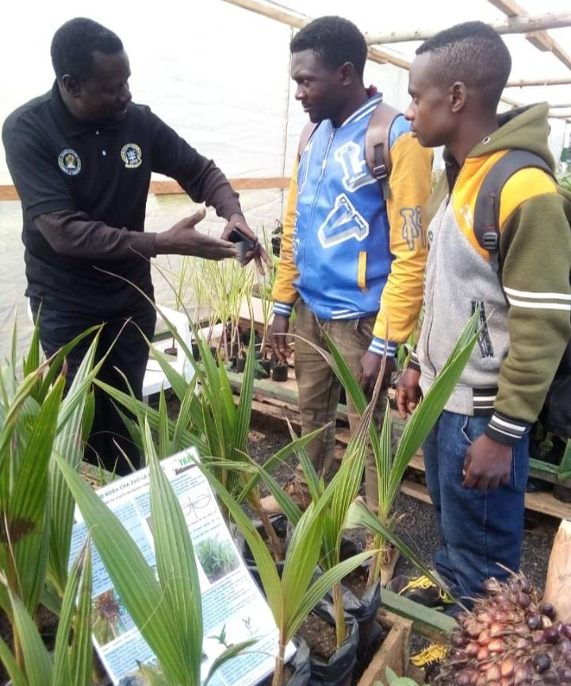
Picture 8:(Left side)Centre Manager of TARI Mikocheni,Dr.Fred Tairo explaining to agricultural stakeholder on the use of media in propagating pineapple seedlings at the tissue culture laboratory,(right side) Head of Agronomy unit, Mr.Kitilu Mganga explaining on the coconut management practices to youth farmers.

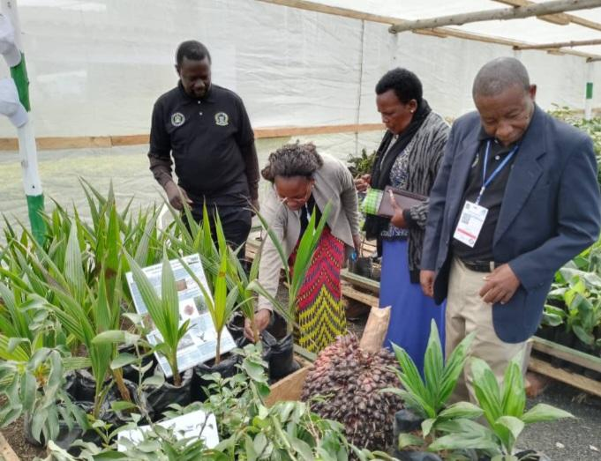
Picture 10: Ms.Vaileth Mwaijande elaborating on Coconut(East African Tall) variety to the Centre Director of TARI Naliendelee, Dr.Fortunatus Kapinga.

The following are pictures taken during Nanenane Exhibitions at Mwl.J.K.Nyerere grounds in Morogoro:
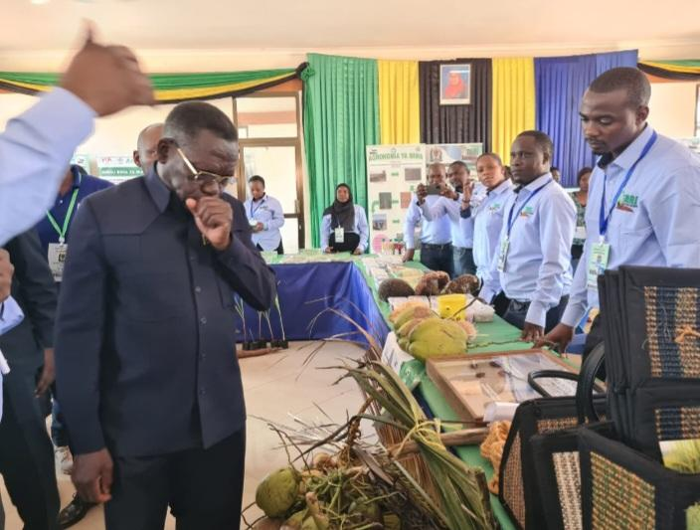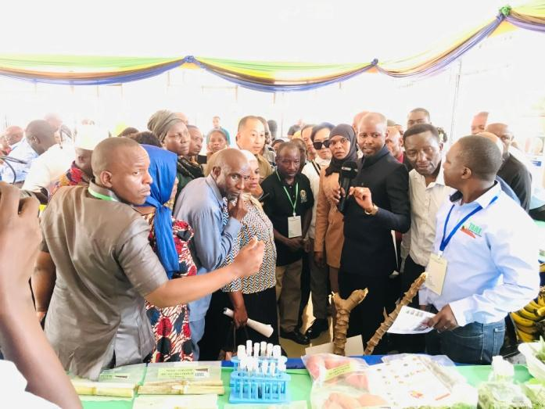
Picture 11: (Left side) Former Prime Minister of Tanzania, on. Mizengo Pinda listening from Mr.Essau Losujaki explaining on pests affecting coconut plant,(right side)District Commissioner of Handeni, Hon.Albert Msando(with black suit) during the visit at TARI pavilion at Mwl.J.K.Nyerere Hub in Morogoro

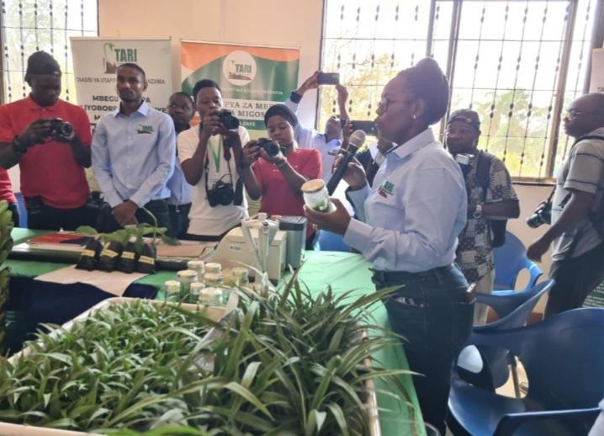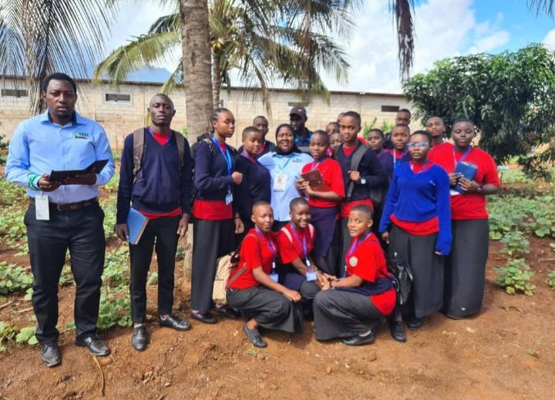
Picture 12:(Left side) Head of Biotechnology department, Dr. Happiness Mollel elaborating to Hon. Mizengo Pinda (Former Prime Minister) not seen in the photo on Tissue culture technology, (right side) Center Coordinator of Technology Transfer and Partnership,Ms.Vidah Mahava (at the center with light blue shirt) with Agricultural Officer,Mr. Abdul Kyobya(first left) after training students on the benefits of intercropping coconuts with other crops
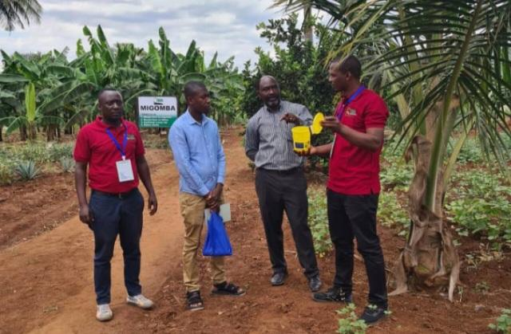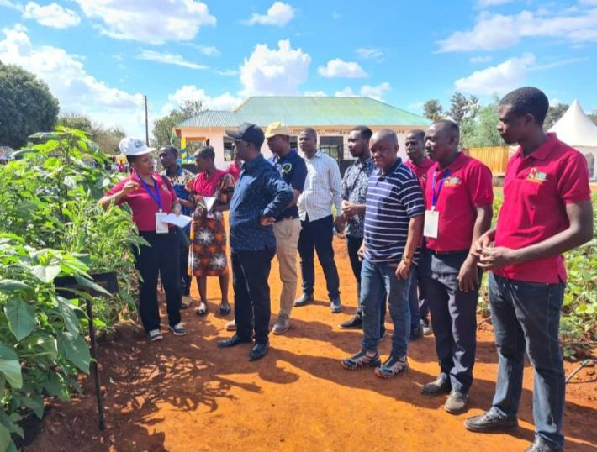
Picture 13:(Left side) Head of Pest Control Unit, Mr.Essau Losujaki explaining the use of fruit fly trap on mangoes fruits,(right side) Ms.Zaina Mziray explaining elaborating on the benefits of using improved vegetables varieties to the overall consumer health.

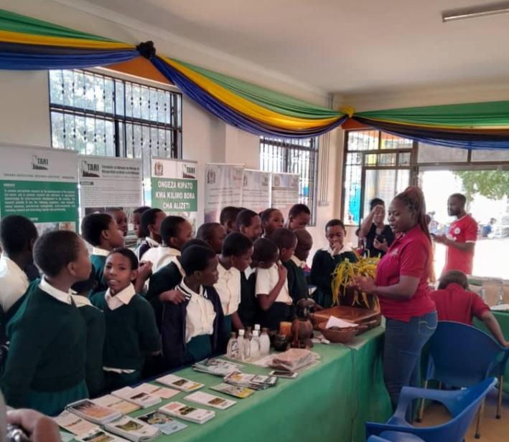
Picture 14: Ms.Suzana Theonest explaining to students on the use of coconut by products including virgin coconut oil, coconut husk and some decoration furniture from coconut tree

2.2.3 Stakeholders reached in TARI Mikocheni substations.
In this reporting time total number of 416 Farmers (257 Males and 159 Females) were reached in Mikocheni substations, in which 191 Farmers (99 Males and 92 Females) visited Chambezi sub-station and 225Farmers (158 Males and 67 Females) visited Mkuranga sub-station requested on buying coconut, mangoes and oranges seedlings, asking different questions concerning management and pest control in coconuts, mangoes and oranges.

Table 4: Stakeholders reached with Technologies Disseminated from TARI Mikocheni Centre to various places.
Place | Stakeholders | Technologies disseminated
Chambezi | 191 Farmers (99 Males and 92 Females) | 1. Coconuts intercropped with mangoes and orange to control pests through weaver ants which feed on coreid bugs.  2. Mechanical remover of beetles using hook.  3. Cultural control by cleaning field removing dead logs which are breeding site for beetles.  4. Using of Traps (Pheromones, PVC Pipe and Tin) to trap beetles.
Mkuranga | 225Farmers(158 Males and 67 Females) | 1. Coconuts intercropped with mangoes and orange to control pests through weaver ants which feed on coreid bugs.  2. Mechanical remover of beetles using hook.  3. Cultural control by cleaning field removing dead logs which are breeding site for beetles.  4. Using of Traps (Pheromones, PVC Pipe and Tin) to trap beetles.
Total number of technologies disseminated |  | 4

3. Knowledge Management and communication
3.1 TARI Website Content management
Different information was uploaded to TARI website as shown by the table below:
Table 5: Type and numbers of information uploaded to TARI website from July to September, 2023
Centre | Type of information uploaded | Number/frequency | Remarks/any feedback | Challenges
TARI – Mikocheni | News | 0 | - | Lack of facilities including Internet, Computer, Scanner, Photocopy machine and Mobile phones
 | Publications | 2
 | Images/photos | 0
 | Videos | 1

3.2 Information Education and Communication materials
In this reporting time planned number of materials to be disseminated were 1525 leaflets on coconut, tissue culture and improved vegetables where 1125 leaflets were managed to be disseminated.
Table 6: Information materials produced and distributed
Centre | Number of print communication materials
 | Posters | Signboards | Fliers | Brochures | Banners | Wheel covers | Leaflets | Others specify
TARI – Mikocheni | 3 | - | - | - | - | - | 1125 | -

4 TARI Visibility
4.1 Signboards: Nil
Preparation of signboards: areas fixed with signboards with uniform format and design across TARI Centres

4.2 Mass media prepared by TARI Mikocheni from July to September, 2023
In this reporting period Mass Media planned to air 15 TV while aired 5 TV. Also planned Radio were 15 while aired 3 radio, also Planned 6 newspapers actual released were 0 also Planned Social Media were 185 while aired Social Media were 126 as shown on the table 6 below.

Table 6: Number of TVs, radio, newspapers and social media produced and disseminated
Centre | Numbers prepared/hired/made/received
TARI – Mikocheni | TV | Radio | Newspapers | Social media | Short Messages | Phone calls | Others specify
 | 5 | 3 | 0 | 126 | 73 | 82 | -
5.0 Strengthening Partnerships and Collaboration

5.1 Meetings/ conferences/ symposia/ workshops
One (Female) Senior Research Officer who is the Centre Coordinator of Technology Transfer and Partnership (TTP) attended a workshop from 17th to 22th September 2023 in South Africa. The main focus is on strengthening knowledge and to attend the Regional Information Communication Knowledge Management Workshop on Research to Extension Video Production and Social Media Engagement. Two workers one researcher (Male) from Social Economy Unit and Supplies Officer (Female) from Procurement Management Unit (PMU) attended meeting from 25th to 29th September 2023 at Mkwawa University College of Education (MUCE) in Iringa where the main objective was to be trained on National Electronic Procurement System (NEST).

Table 6: Meetings/conferences/symposia/workshops conducted/attended by TARI staffs
No | Tittle/themes | Dates | Venue | Partners | Type of event(workshop/Meeting
1. | Technology Transfer and Partnerships | 17th to 22nd September 2023 | Holiday Inn Johannesburg- East Rand area in South Africa | CCARDESA, SADC Members States, ASARECA, CORAF, AFAAS, FARA | Workshop
2. | Training of National Electronic Procurement System (NEST) | 25th to 29th September 2023 | Mkwawa University College of Education (MUCE) | MINISTRY OF AGRICULTURE, MINISTRY OF HEALTH,TARILI,ASA,TPA,TRA,AIR TANZANIA, etc. | Meeting

5.2 Internship Programmes
In this reporting time TARI Mikocheni received 11 Field practical students 5 (1 Male and 4 Females) from University of Dar es Salaam and 6 (2 Male and 4 Female) from University of Dodoma in July 2023.

Table 8: Number Intern students attached to the Centre
Centre | Type | From | Number
Mikocheni working in Biotechnology Unit (Molecular Biology Laboratory) | Field Practical Students | University of Dares salaam | 5(1 Male and 4 Females)
Mikocheni working in Biotechnology Unit (Tissue Culture Laboratory) | Field Practical Students | University of Dodoma | 6(2 Male and 4Female)

5.3 Strengthen partnership and Capacity building
Two Assistant Researchers (Male and Female) from Zanzibar Research Institute (ZARI), were trained at TARI Mikocheni Tissue culture laboratory in order to get knowledge which will build their capacity on Tissue culture technology. Tissue culture involves multiplication of various crops using respective tissue of such crop such as sisal, pineapple, cassava, sweet potatoes, banana, etc. This training took duration of one week.

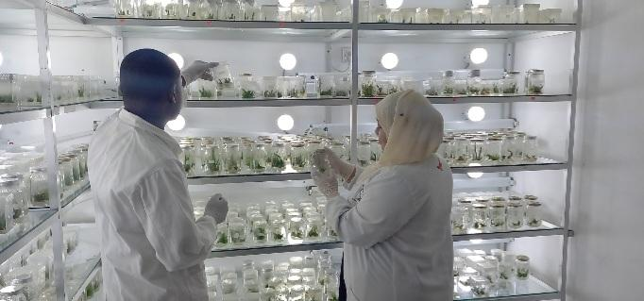
Picture 15: Assistant Researchers from Zanzibar Agriculture Research Institute (ZARI) during the training on Tissue culture technology at Mikocheni Tissue culture laboratory

5.4 Visitations
Total number of 47 farmers (37 Males and 10 Females) stakeholders visited the Centre for different purposes from July to September 2023 as shown in table 9 below.

Table 9: Visitors visited Mikocheni Centre
S/No | Date of the visit | Type of visitors | Total number | Aim of the Visit
 | 14th July 2023 | Farmers from DSM | 5 (3 Males and 2 Females) | They wanted to buy coconut seedlings
 | 18th July 2023 | Farmers from DSM | 4(2 Females and 2 Males) | They wanted to get education and buy various crops of coconut, pineapple, oil palm seedlings
 | 20th July 2023 | Journalist from IBN AFRICA Television | 1 Male | He wanted to broadcast with TARI on different matter pertaining coconut production
 | 27th July 2023 | Farmer from Mtwara | 1 Male | He wanted to get coconut seedlings
5. | 28th July 2023 | Individual farmer from DSM | 1 Male | He wanted to buy different kinds of fruits seedlings and he was directed to Tengeru
6. | 31st July 2023 | Individual farmers from Bunju-DSM | 1 Male | He wanted to buy coconut seedlings
7. | 10th August 2023 | Farmer from DSM | 1 Male | He wanted to buy coconut, mangoes and banana seedlings
8. | 14th August 2023 | Ambassador from LANDMATRIX LTD | 1 Male | He wanted to advertise on Insurance on vehicles, plots, residence and accidents
9. | 16th August 2023 | Farmers from DSM | 2 Males | They wanted to buy coconut seedlings
10. | 17th August 2023 | Farmer from Mtwara | 3(1 Male and 2 Females) | They wanted to get coconuts, cashewnuts, cardamon, garlic and cloves seedlings, they were directed to TARI Tengeru.
11. | 21st August 2023 | Individual farmers from DSM | 2 Males | He wanted to buy pigeon peas and cassava seedlings and they were directed to TARI Ilonga and Kibaha
12. | 22nd August 2023 | Workers from REAL ESTATE LTD | 3(1 Male and 2 Females) | They wanted to speak with Mikocheni workers on selling their plots for residence
13. | 23rd August 2023 | Journalist from Eat Africa Radio and Science Media for Africa | 2(Males) | They wanted to get access on production of video and radio conversation on coconut production
14. | 24th August 2023 | Farmer from DSM | 1 Male | He wanted to get education on cassava production
15. | 4th September 2023 | Farmer from DSM | 1 Male | He wanted to buy coconut seedlings
16. | 6th September 2023 | Farmer from DSM | 1 Male | He wanted to get rice seeds for production
17. | 12th September 2023 | Farmer from DSM | 1 Male | He wanted to buy coconut seedlings
18. | 13th September 2023 | Workers from AQUAVITA | 2 Males | They wanted to sell bottle less office water coolers.
19. | 15th September 2023 | A Reporter from Science Media for Africa | 1 Male | He wanted to take documentary on coconuts pests and production
20. | 18th September 2023 | Individual farmer from DSM | 1 Male | He wanted to buy coconut seedlings
21. | 21st September 2023 | Individual farmers DSM | 2 Males | They wanted to get education Soya beans production
22. | 22nd September 2023 | Farmer from Tanga | 1 Female | She wanted to get coconut education and seedlings
23. | 26th September 2023 | Farmers from Tanga | 4 Males | They wanted to buy coconut seedlings
24. | 27th September 2023 | Student from Arusha University | 1 Male | He wanted to sell books related to human health and well being
 |  | Farmers from DSM | 3(2 Males and 1 Female) | They wanted to buy coconut, cassava and papaya seedlings
 |  | Individual farmer from Moshi | 1 Male | He wanted to buy coconut seedlings

5.5. Challenges during Saba Saba, Nane Nane exihibitions and at the Mikocheni centre
- Lack of processing machines for different crops which result into low production of products compared to higher demand of stakeholders visiting TARI
- Lack of good camera and video shouting equipment which results to poor quality of videos and pictures which destroy the image of the Institute
- Lack of tents in crop demo plots which makes technologies delivery process harder in case of very hot day and heavy rainfalls especially during the Nane Nane Exhibitions
- Shortage of postharvest products from crops compared to higher demand of stakeholders visiting TARI pavilion hence TARI should collaborate with other entrepreneurs to increase products during exhibitions
- Lack of working equipment to farm guards at TARI Mikocheni sub-stations (Chambezi and Mkuranga), i.e. Raincoats, gumboots and defensive weapon against invaders
- Lack of farming equipment i.e. tractors for clearing and tillage in coconuts plantations
- Coconuts thieves due to surrounded bushes and shortage of farm guards at Chambezi and Mkuranga sub-stations
- Limited funds for TTP activities at the Centre which hinder publications of updated news and scientific findings and development of very important dissemination materials like brochures, leaflets, banners, posters, calendars etc.

5.6. Conclusion and Recommendations
- There should be enough budget for preparing different publications and different dissemination materials like brochures, leaflets, banners, posters, calendars etc.
- Different products produced by TARI should attain BRELLA and TBS which are the products regulators prior to distribution
- Directors and Managers should be given enough time and funds to prepare all the requirement needed for Saba Saba exhibition so as to avoid uncertainties arising during the exhibitions
- Postharvest unit should be innovative in producing more advanced products which satisfy stakeholder’s needs
- The Institute should have business cards for various stakeholders for easy communication and follow up of different official issues
- There should be updated telephone numbers on website so that customers get in touch with the service on time
- TARI exhibition pavilion at Mwl. J.K. Nyerere grounds should be large enough to accommodate all centers
- There should be a collaboration between TARI Mikocheni and furniture manufacturers stakeholders which will increase value addition by producing various wood products resulted from coconut timber
- Tents should be provided to crop demo plots in hub which will make the delivery process easier especially in banana and coconuts demo plots
- Due to the lack of class groups, there is a need to form a plan which will motivate stakeholders to be interested in joining group class for training
- During the Nane Nane day the all exhibitors should have the same uniforms which means TARI should prepare enough uniforms for exhibitors
- Working equipment to farm guards should be provided to increase their efficiency and salary should be paid on time to meet the demands of the laborers
- Modern tractors should be provided for land clearing in order to reduce bushes which reduce productivity, hibernate thieves and wild animals
- Adequate farm guards should be hired to ensure maximum security, especially at Chambezi and Mkuranga sub-stations where coconut production is higher. There is a very big demand for coconuts and coconut seedlings hence the farm guards should be motivated in different ways in order to take care of the farms for more production.

